**Design of Light Switch**

**Lab no# 07**



Spring 2022

CSE-308L Digital Systems Design lab

Submitted by: **Ashfaq Ahmad**

Registration No: **19PWCSE1795**

Class Section: **B**

“On my honor, as student of University of Engineering and Technology, I have neither given nor received unauthorized assistance on this academic work.”

Student Signature: ______________

Submitted to:

**Dr: Ma’am Madeha sheer**

**June** 11, 2022

**Department of Computer Systems Engineering**

**University of Engineering and Technology, Peshawar**

**Objective:**

* Build a light switch controller such that when the push button is pressed the light if “off” turns “on” and if “on” turns “off”.

**Block Diagram:**

* Connect the button input to a dip or push button on the S6 board and light output to LED.

**Synchronizer Circuit:**

These two registers are two D_FFs.

**Level to Pulse FSM:**

Given register is D_FFs.

**Task 01:** Design a Level to Pulse Converter:

**Description:**

For level to pulse first we convert user input (button) to synchronized input by using two D_FFs (we can also use one but two for accurate synchronization).

We can also synchronize user input by simple assigning it to other variable on clock edge in separate module.

**Block Diagram:**

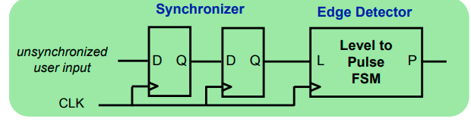

**State Transition Diagram of Level to Pulse converter:**

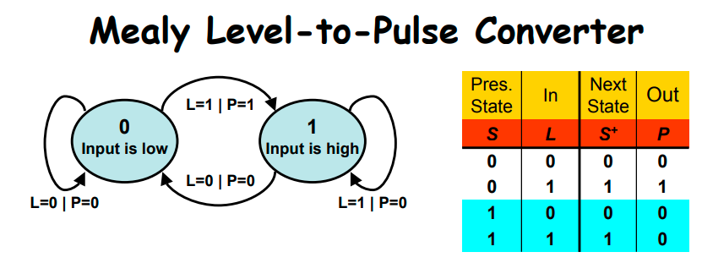

**In case of Moore machine,**

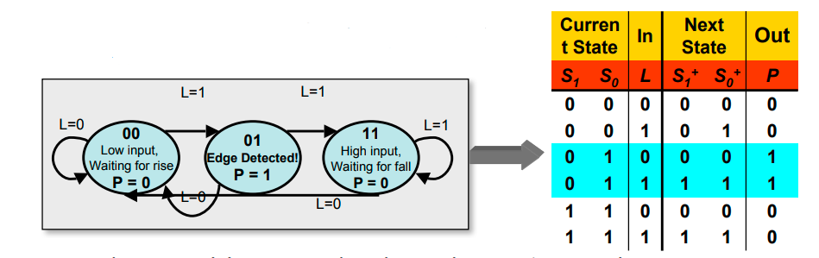

**Source Code:**

module L2P_Converter(out,in,clk_100Mhz,reset);

input in,clk_100Mhz,reset;

output reg out;

wire clk_1Mhz,syn_out;

parameter s0=0,s1=1;  //posiible stats . signal level either 1 or 0.

reg state,next_state;

clk_divider cd(clk_1Mhz,clk_100Mhz,reset);

synchronizer syn(syn_out,in,clk_1Mhz,reset);

always @(*)           //star '*' means this block is sensitive to all inputs used in it.

begin

       case(state)    //stats diagram code

       s0:

            if(syn_out)

                begin

                     out=1;

                      next_state=s1;

                end

                else

                begin

                     out=0;

                      next_state=s0;

               end

       s1:

            if(syn_out)

                begin

                     out=0;

                      next_state=s1;

                end

                else

                begin

                     out=0;

                      next_state=s0;

               end

      endcase

end

//we can also remove given always block and add default case in case statement.

always @(posedge clk_1Mhz)  //reset block

begin

       if(reset)

               state=s0;

       else

                 state=next_state;

end

endmodule

module clk_divider(clk_1Mhz,clk_100Mhz,reset);  //clock divider

input clk_100Mhz,reset;

output reg clk_1Mhz;

integer c;    //we can also delacre c as a reg.

always @(posedge clk_100Mhz)

        if(reset)

                  begin

                  c=0;

                  clk_1Mhz=1;

                  end

                  else

                  begin

                  c=c+1'b1;

                  if(c==50000000)

                  begin

                                             clk_1Mhz=~clk_1Mhz;

c=0;

 end

 end

endmodule

module D_FF(Q,D,clk_1Mhz,reset);  //D_FF

input D,clk_1Mhz,reset;

output reg Q;

always @(posedge clk_1Mhz)

       if(reset)

                 Q=0;

         else

                 Q=D;

endmodule

module synchronizer(syn_out,in,clk_1Mhz,reset);   //synchronizer

input in,clk_1Mhz,reset;

output syn_out;

wire FF1_out;

D_FF ff1(FF1_out,in,clk_1Mhz,reset);

D_FF ff2(syn_out,FF1_out,clk_1Mhz,reset);

endmodule

**Output:**

* Input is Dip switch no 1 and reset is dip switch no 8.
* States are s0=0 and s1=1.

In=0; state=s0; out=0; next state=s0.

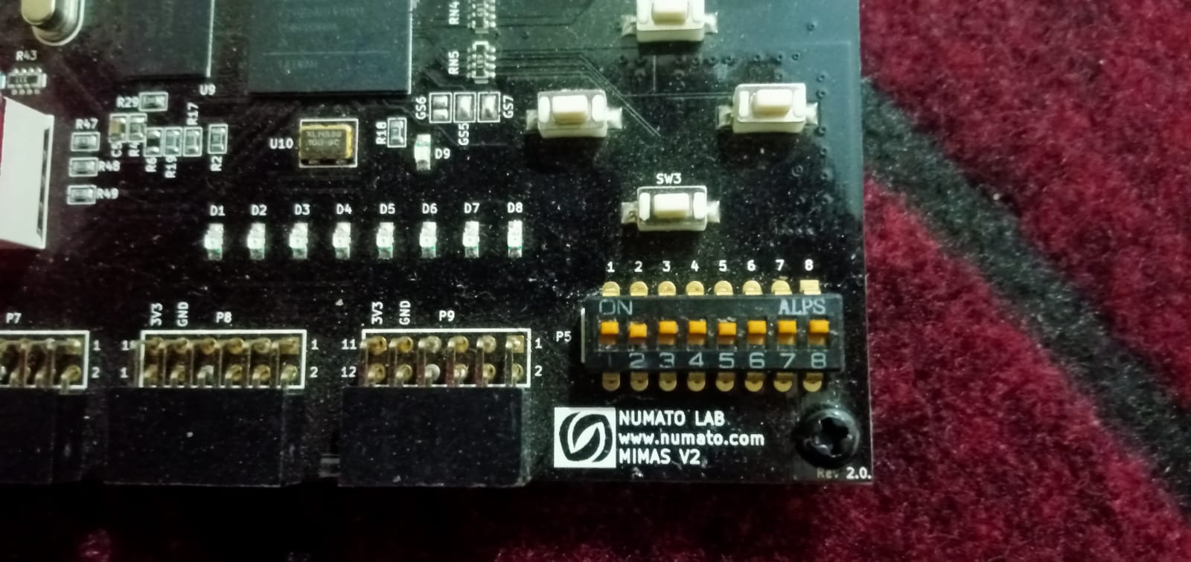

In=1; state=s0; out=1; next state=s1.

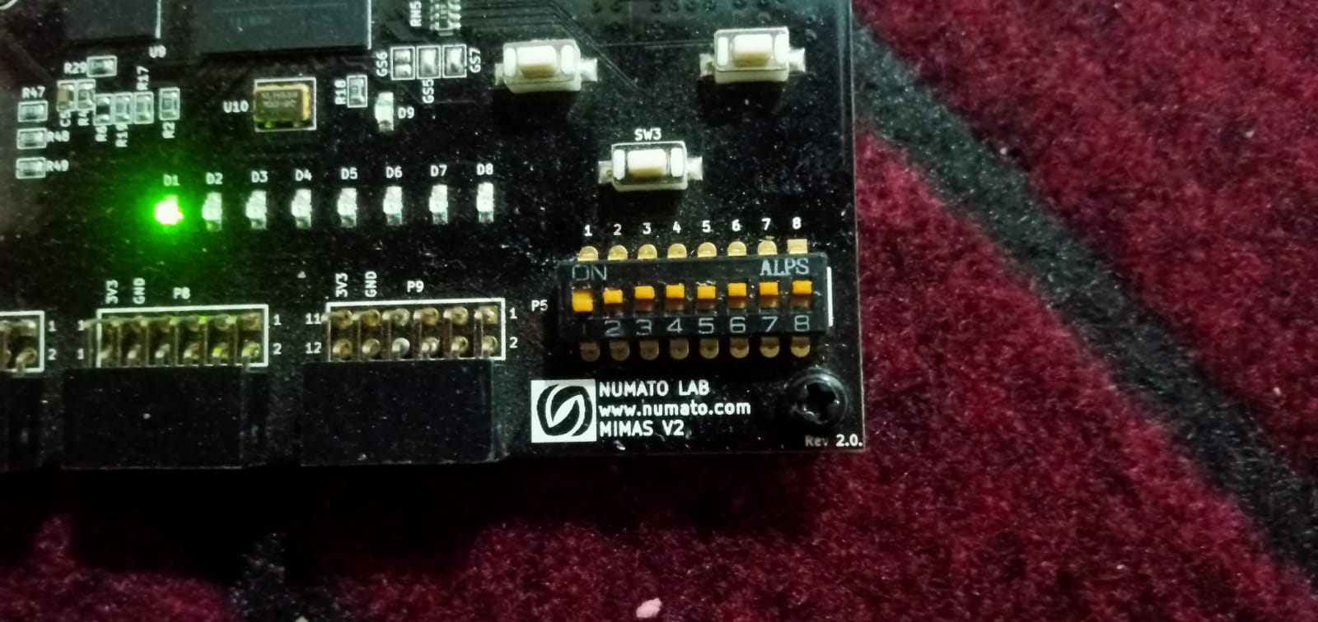

In=1; state=s1; out=0; next state=s1.

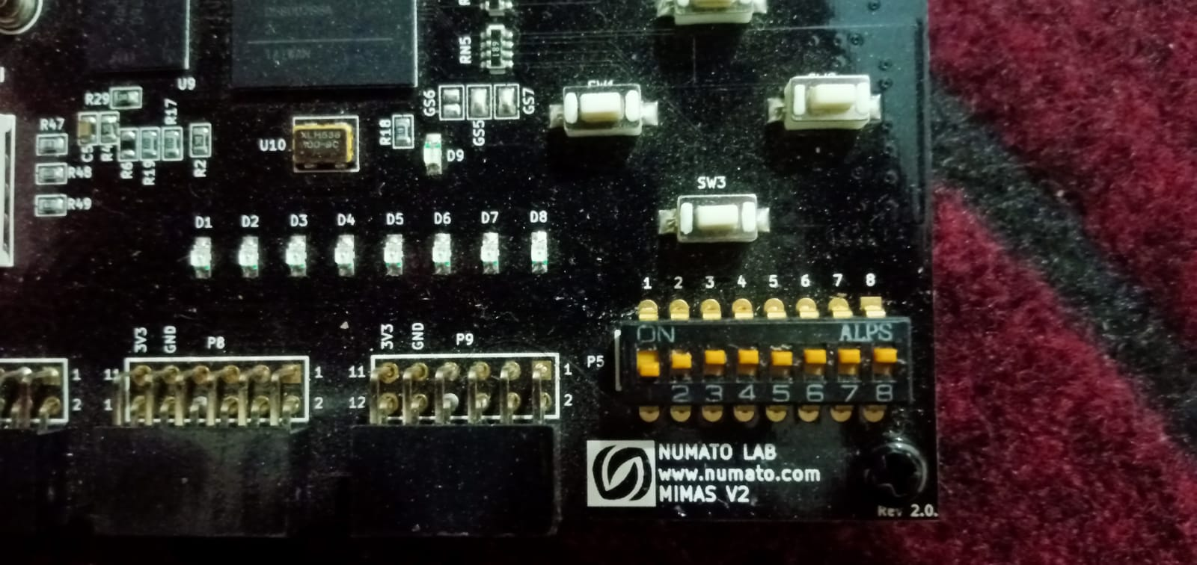

In=0; state=s1; out=0; next state=s0.

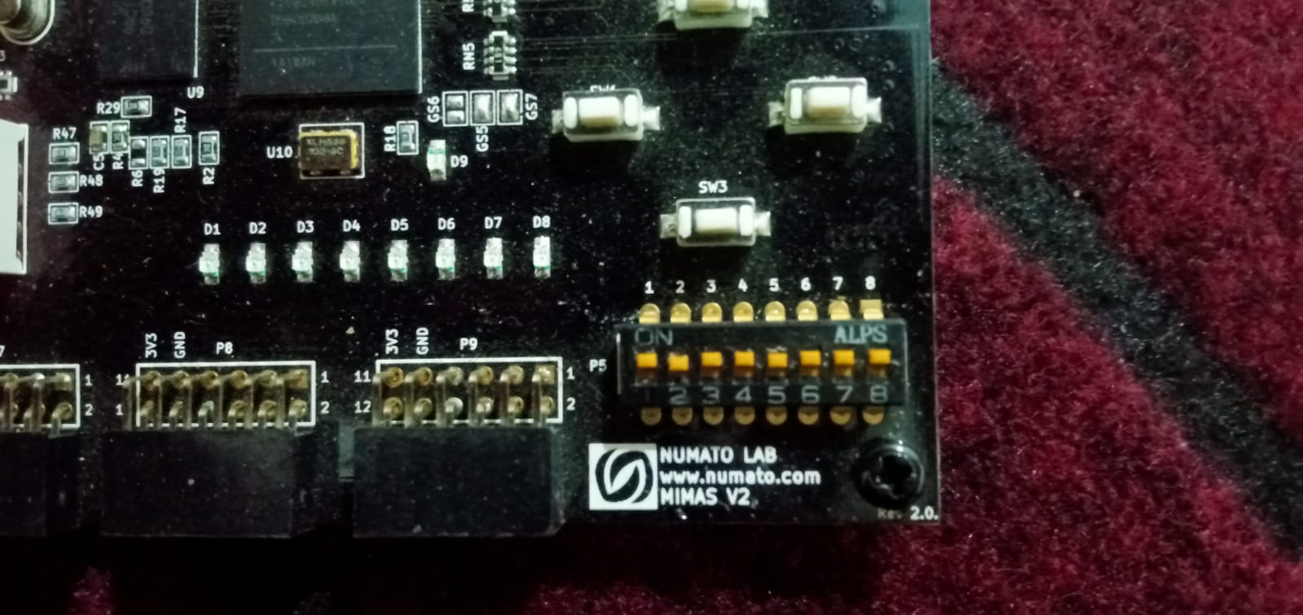

**Reset state:**

Even in=1 but out=0 and state=s0.

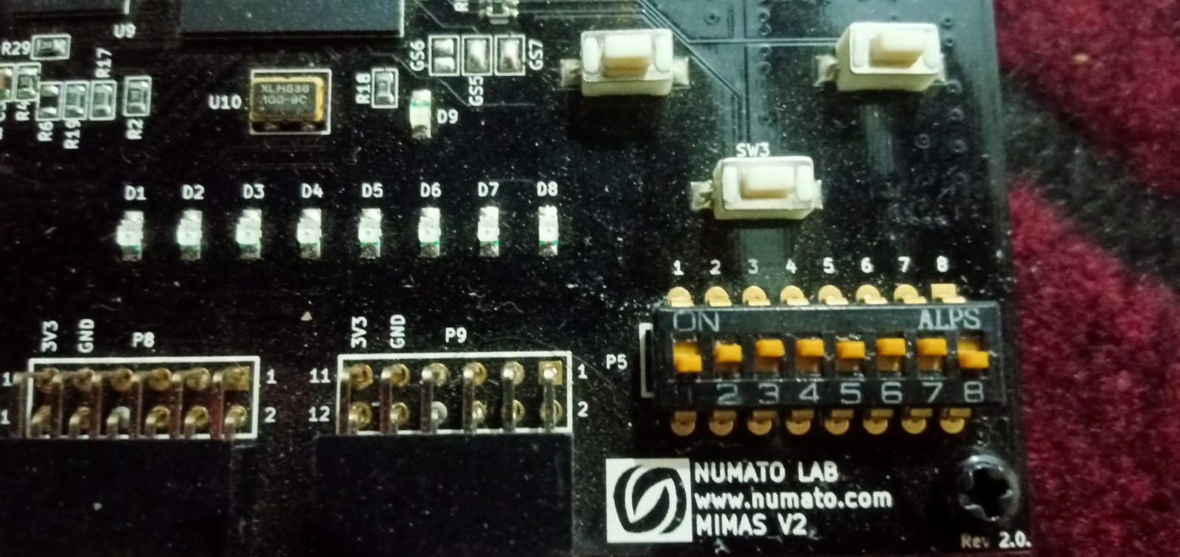

**Task 02:** Design a light switch.

**Block Diagram:**

**States Transition Diagram:**

**Mealy Machine:**

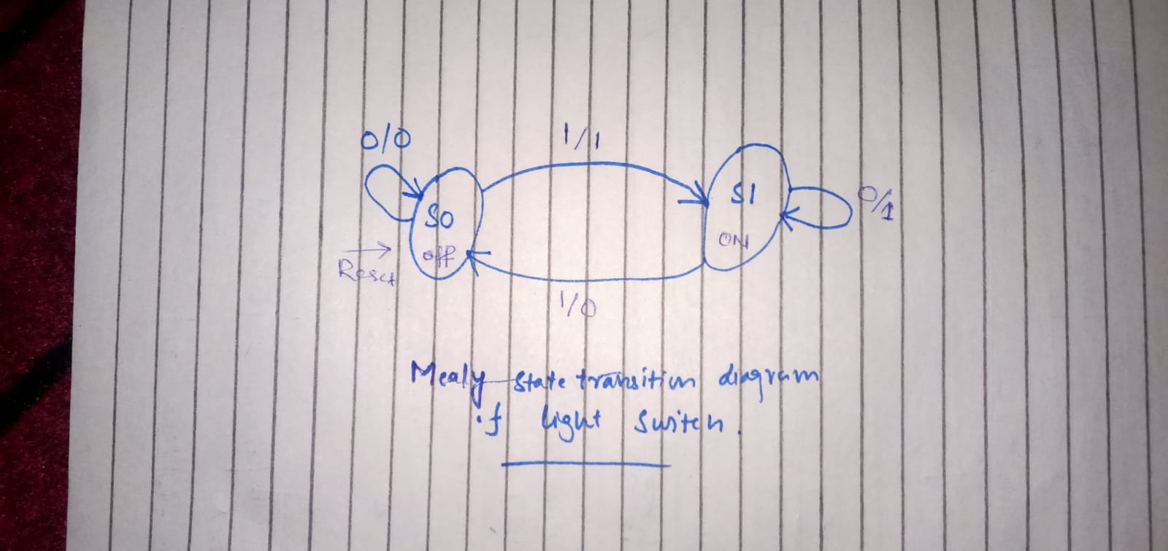

**Moore Machine:**

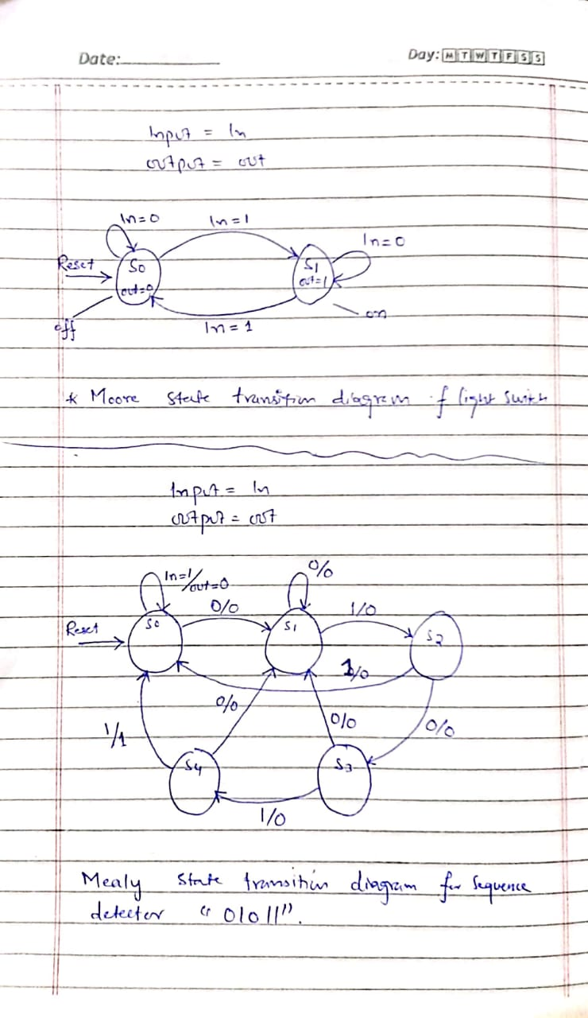

**Source Code:**

module light_switch(switch_out,in,clk_100Mhz,reset);  //light switch main module.

input in,clk_100Mhz,reset;

output reg switch_out;

wire clk_1Mhz,syn_out,L2P_out;

reg state,next_state;

parameter s0=0,s1=1;

clk_divider cd(clk_1Mhz,clk_100Mhz,reset);

synchronizer syn(syn_out,in,clk_1Mhz,reset); //i can also instantiate synchronizer in L2p_converter block.

L2P_Converter l2p(L2P_out,syn_out,clk_1Mhz,reset);

always@(*)     //light switch state digram code

       case(state)

       s0:

          if(L2P_out)

             begin

                   switch_out=1;

                   next_state=s1;

             end

           else

             begin

                      switch_out=0;

                         next_state=s0;

            end

        s1:

           if(L2P_out)

            begin

                      switch_out=0;

                        next_state=s0;

            end

            else

            begin

                      switch_out=1;

                         next_state=s1;

         end

     endcase

//we can also remove given always block and add default case in case statement.

always@(posedge clk_1Mhz)

      if(reset)

              state=s0;

      else

              state=next_state;

endmodule

module clk_divider(clk_1Mhz,clk_100Mhz,reset);  //clock divider

input clk_100Mhz,reset;

output reg clk_1Mhz;

integer c;    //we can also delacre c as a reg.

always @(posedge clk_100Mhz)

            if(reset)

            begin

                    c=0;

                    clk_1Mhz=1;

            end

            else

            begin

                    c=c+1'b1;

                    if(c==20000000) //here i reduced value of c so the output clock is not 1_Mhz.

                    begin

                            clk_1Mhz=~clk_1Mhz;

                            c=0;

                    end

            end

endmodule

//I have designed synchronizer without using Flip flops. but funcationality same.

module synchronizer(syn_out,in,clk_1Mhz,reset);   //synchronizer

input in,clk_1Mhz,reset;

output reg syn_out;

reg FF1_out;

always @(posedge clk_1Mhz)

       if(reset)

         syn_out=0;

         else

         begin

             FF1_out=in;  //here also two FF will be generated. but coding method is different.

              syn_out=FF1_out;

         end

endmodule

module L2P_Converter(L2P_out,syn_out,clk_1Mhz,reset); //level to pulse converter.

input syn_out,clk_1Mhz,reset;

output reg L2P_out;

parameter s0=0,s1=1;  //posiible stats . signal level either 1 or 0.

reg state,next_state;

always @(*)           //star '*' means this block is sensitive to all inputs used inside it.

begin

       case(state)    //stats diagram code of L2P.

       s0:

            if(syn_out)

                begin

                     L2P_out=1;

                      next_state=s1;

                end

                else

                begin

                     L2P_out=0;

                      next_state=s0;

               end

       s1:

            if(syn_out)

                begin

                     L2P_out=0;

                      next_state=s1;

                end

                else

                begin

                     L2P_out=0;

                      next_state=s0;

               end

      endcase

end

always @(posedge clk_1Mhz)  //reset block

begin

       if(reset)

               state=s0;

       else

                 state=next_state;

end

endmodule

**Output:**

* The input Pin is Dip switch no 1 and reset switch is dip switch no 8.
* States are s0=0 and s1=1.

In=0; state=s0; out=0; next state=s0.

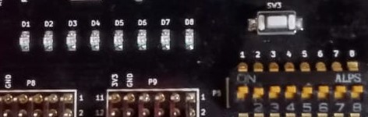

In=1; state=s0; out=1; next state=s1.

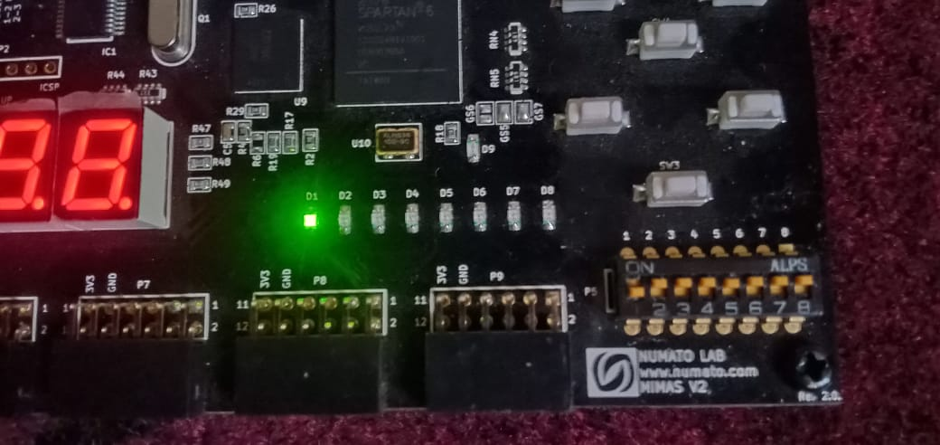

In=0; state=s1; out=1; next state=s1.

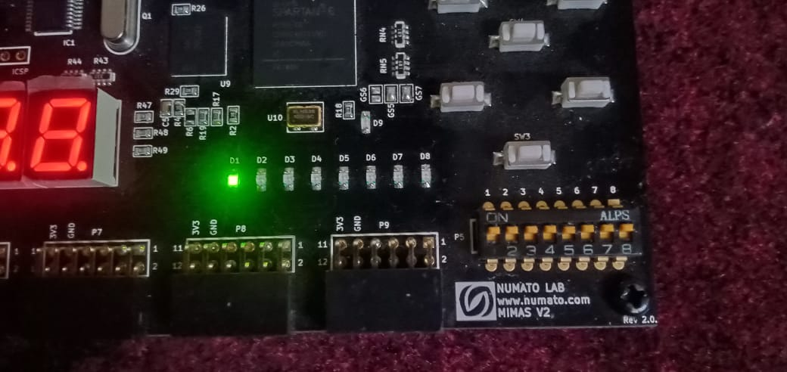

In=1; state=s1; out=0; next state=s0.

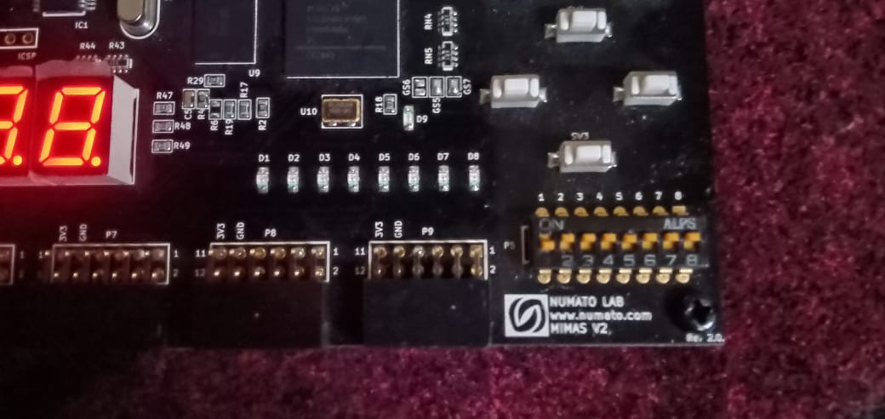

**Reset state:**

Even input is one but output is zero and state is s0.

